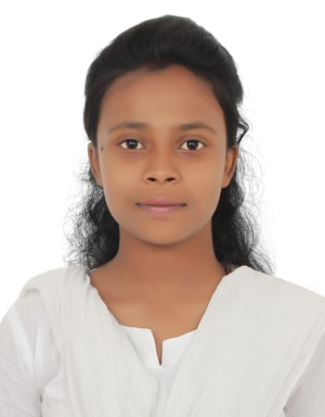 No.119/2, Green Park Layout,
Nithya Magilichi. D
Bachelor of Commerce
Behind Garden City College,
Hallehalli, K. R Puram,
Bangalore – 560036.
Mobile:-9739444459
E-mail:- nithyadrg2607@gmail.com

CAREER OBJECTIVE:

- To associate and to have a bright and challenging career, in a professional and growing organization, which would enable me to contribute my knowledge for a comprehensive growth of the organization in a learning environment.
- To secure a challenging position in a reputable organisation to expand my learning’s, knowledge and skills.
- To secure a responsible career opportunity to fully utilize my training and skills, while making a significant contribution to the success of the company.
- To give my fully concentration and commitment towards the organization.
- To be punctual in whatever work is assigned to me.

STRENGTHS:
- Quick learner.
- Competitiveness.
- Teamwork.
- Problem solving.
- Flexible
- Leadership
EXPERIENCE:
Organization- Cameo Corporate Services Pvt Ltd
Designation- Telecaller
Roles and Responsibilities: Had to handle the inbound calls and target of the firm. It was a great learning experience for me, knowing about the customer services. As I wanted to complete B.com final semester I had to quit this job in 2 months.
Organization- Cognizant
Designation- Process excecutive
Roles and Responsibilities: I have been placed in FLOOD team. I need to give determination for the properties. It is US based shift. I have more than 1 year 5 months of experience. I started my job on march 26th of 2021. And currently I am serving notice period. Which is for 3 months duration.
ACADEMIC QUALIFICATIONS:

S. No | Certification | School/Institution | University | Year | Percentage
1 | Bachelor of Commerce | Silicon City Degree College,  Bangalore | Bengaluru University | 2017-2020 | 75%
2 | 2nd PUC | Silicon City Degree College,  Bangalore | Board of PUC | 2015-2017 | 67%
3 | SSLC | Christ Global Residential School | SSLC | 2015 | 76%

TECHNICAL SKILLSET
- MS Office
- Tally ERP 9 with GST
- Typing
- Basic Windows

POFESSIONAL SKILLSET
- Specialization in Accounting and Taxation

Hobbies:

Singing, playing carrom, Writing Personal dairy.

PERSONAL PROFILE:

Father Name : DAVID NESARAJ
Mother Name :REBECAL
Date of Birth : 16-03-1999
Gender : Female Languages Known : English, Kannada, Hindi, Telugu and Tamil
Nationality : Indian Marital Status : Single

DECLARATION:

Hereby, I declare that the information given above is accurate and correct in all respect.

Date:
Place: Bangalore
NithyaMagilichi. D

